Introduction
What does a 16th-century cipher device have to do with Bitcoin? Why does the history of paper money help us put today’s stablecoins into perspective? What do terms like blockchain, public/private key, wallet, and mining mean? The special exhibition “Crypto, what?” explores the historical roots of today’s crypto assets in cryptography, computing, and global connectivity. Using Bitcoin as an example, it explains the basic principles of a decentralized crypto asset and how a blockchain works. At the same time, historical forms of money are explored in relation to current developments in crypto assets. These analogies yield surprising insights that lead to very basic monetary questions: What determines value? What rules apply? How is trust established? And who bears the risks?
Exhibition Area 1: Cryptography, Computer History, and Digital Networks
- Secret Messages in Antiquity: Encryption and Seals
How can messages be sent so that others cannot understand them? People have probably always asked this question. In antiquity, one solution was to secure a message with a beeswax seal. A broken seal indicated that the message had been read. Other solutions were also developed: texts, or the letters within them, were altered so that only the intended recipients could read them.
The scytale is a documented example of this approach from ancient Sparta. A strip of leather was wound around a wooden rod in a spiral, and the message was written across the turns of the strip. Once unwound, the message became unreadable. Only by wrapping the strip around a rod of the same diameter could the letters be arranged in the correct order again.
The so-called Caesar cipher, whose invention is attributed to Julius Caesar, works even more simply: each letter is shifted to a fixed number of places in the alphabet. For example, A becomes D, and B becomes E. Anyone who knows the “key”, which means the number of places to shift, can decode the message.
Both methods are easy to crack. Yet they demonstrate a principle that still applies today: information can be transformed so that only those who know how to decode it can understand it. This principle is called cryptography. It is the first of three foundations on which digital payments and digital money would later be built.

- Systematic Encryption: The Cryptographic Dividers and the “Permutation Machine”
Ancient methods had a drawback: once their underlying principle was known, messages could often be deciphered quickly. This gave rise to a contest between encrypting and decrypting information that continues to this day. New methods aim to make messages ever more secure, while others continually seek ways to decipher their contents.
One example is the cryptographic dividers of 1633, which use a simple mechanism: each letter of the alphabet could be converted into a line of a specific length by adjusting the distance between the instrument’s points. Sender and recipient each needed an identical instrument, as the message could only be deciphered if both used the same setting.
The “permutation machine” is a cipher device dating from 1587. Originally equipped with 24 individually rotating brass disks, it used a considerably more complex encryption method. Each disk bore 24 letters (J=I, U=V), allowing each letter in a word to be shifted by a different number of places. Without the “key”, the information specifying the positions of the disks relative to one another, and thus the shifts to apply, a message was difficult to decode. The object demonstrates an early mechanical method for systematically encrypting and decrypting language.

A Closer Look: Other Encryption Methods
Other tools made encryption more complex. These included cipher tables and codebooks known as nomenclators, in which names, places, or entire words were replaced with other symbols. From the 15th century onward, such methods played a particularly important role in European diplomacy, which relied on extensive networks of traveling couriers and envoys. In “black chambers,” royal courts encrypted messages and deciphered intercepted correspondence. The Saxon court also had a “black chamber,” located within the postal office itself so that incoming and outgoing letters could be monitored. Such practices remained commonplace in East Germany during the Cold War. Today, the privacy of correspondence is explicitly protected by Germany’s constitution, although digitization and the privatization of postal and communications services are weakening that protection.

- A Machine That Calculates: The Leibniz Calculating Machine
In the 17th century, scholars in several European countries explored whether calculations could be mechanized. One of them was Gottfried Wilhelm Leibniz (1646–1716), who was born in Leipzig. His mechanical calculating machine ranks among the most significant early examples of its kind because it could perform all four basic arithmetic operations: addition, subtraction, multiplication, and division. At its heart was the so-called stepped drum, part of a mechanism of interlocking gears that performed calculations mechanically.
Leibniz took an early interest in the binary number system and was among the first to describe it systematically in writing. This way of representing numbers uses only two digits: 0 and 1. Unlike the decimal system, which uses ten digits, the binary system allows information to be represented using just two states, like a switch that is either on or off.
Today, this principle is fundamental to digital technology. Computers process information internally using binary states. Every photo, every message, and every transaction is represented by sequences of zeros and ones.

- Machines Encrypt: The Enigma
In the early 20th century, the Enigma rotor cipher machine marked a major leap forward in message encryption.
The Enigma offered more possible settings than there are stars in our galaxy, over 150 quintillion in the standard military version. German engineer Arthur Scherbius originally developed it as a commercial product for banks and businesses seeking to protect their communications. The military later adopted the technology for its own purposes. The Enigma used rotating wheels, or rotors, that created a new mapping between letters with every keystroke. It was as if a lock changed completely after every letter.
During World War II (1939–1945), the Enigma was used for military communications by the German armed forces. It formed part of the technical infrastructure of a war waged with contempt for human life that claimed countless millions of victims.
As early as the 1930s, Polish mathematicians, including Marian Rejewski, Jerzy Różycki, and Henryk Zygalski, succeeded in mathematically analyzing how the Enigma worked. Building on this foundation, British cryptologists at Bletchley Park constructed electromechanical codebreaking machines. Alan Turing played a leading role, developing the “Turing–Welchman Bombe” with his team. The first machines entered service in 1940 and were used to crack Enigma encryption.

Exhibition Area 2: How Does Bitcoin Work?
Introduction: From Ideal to Industry
When Bitcoin launched in 2009, “mining” was meant to be as an open, decentralized process: Anyone could join the network with a computer, verify transactions, and generate new blocks. The system promised equality – no central authority, no privileged players.
Today, however, the landscape is dominated by specialized high-performance devices and, in particular, industrial mining farms. In massive warehouses, thousands of ASIC machines operate around the clock. The competition for computing power has become a global business, driven by electricity prices, locational advantages, and investment capital. Individual miners now have little chance of keeping up profitably.
Thus, the balance of power shifted: an infrastructure originally designed to be technically decentralized has given rise to an increasingly economically concentrated landscape. The original ideal of equality clashes with the logic of efficiency, scaling, and profit maximization.
The Bitcoin system challenges the existing order of our global capitalist monetary and financial system: Can a digital asset function as money? Is this possible if it is supported solely by mathematics, computing power, and a global network, with no central authorities, such as states and their central banks, involved?

- Bitcoin System Overview
Bitcoin was introduced in a published proposal in 2008; the network began operating in 2009. The term refers both to a digital payment system and to its unit of value. Bitcoin makes it possible to transfer value over the internet without requiring a bank to keep a central record of transactions. Exchanges and other service providers may nevertheless act as intermediaries in its everyday use.
Bitcoin is regarded as the first successful decentralized crypto asset and the starting point of today’s crypto market. Numerous other crypto assets now exist, including tokens and stablecoins. They do not all follow the same technical principles. Bitcoin, however, marks the beginning of this development, remains in operation, and is still the best-known crypto asset.
Many networked computers maintain and verify a shared transaction history. Digital keys provide proof of who is authorized to spend particular bitcoin. Miners group transactions into blocks and perform computational work to secure their addition to the blockchain. This process also brings new bitcoin into circulation. However, anyone holding, receiving, or sending bitcoin does not need to mine it themselves.
Bitcoin is designed so that no central authority manages the entire system. Instead, it relies on publicly accessible rules, cryptographic checks, and the cooperation of many independently operated computers. The following sections explain the shared ledger, digital keys, mining, blockchain security, and the development of mining hardware.

5.1 A Ledger That Belongs to Everyone
When you hold money in a bank account, the bank does not set aside particular banknotes for you. Instead, it records your account balance and transactions in its database. The bank maintains this ledger centrally and confirms which payments are valid.
Bitcoin takes a different approach. There is no single, central ledger. Instead, numerous independently operated computers, known as nodes, jointly maintain the transaction history. They check new transactions and blocks against the same rules.
New transactions are grouped into blocks. Each block can be compared to a new page in a shared ledger. On average, another block is added approximately every ten minutes.
The blocks containing these transactions are linked: each new block includes a digital reference to the previous one. These successive blocks form a chain: the blockchain. If an earlier block is altered, its “digital fingerprint” no longer matches the references in the blocks that follow. This makes changes to or manipulation of earlier transactions detectable.

A Closer Look: How Blocks Are Linked—Hash Functions
The reference to the previous block is not a simple reference like a page number. It is a hash value, a digital fingerprint. A hash function is a computational procedure that converts data of any length into a fixed-length string. Bitcoin uses SHA-256 for this purpose. When hashing a block header, SHA-256 is applied twice in succession. The result consists of 256 bits and is usually displayed as a sequence of 64 hexadecimal characters.
Two properties make hash functions essential to the blockchain. First, they are extremely sensitive to changes: alter just one character in the original data, and the hash value looks completely different. Second, the function effectively works in only one direction: the original data cannot be reconstructed from the hash value.
Each block header contains the hash of the previous block header. If someone altered an old block, its hash would change, and the reference in the next block would no longer match. To conceal the change, all subsequent blocks and their associated proofs of work would also have to be recalculated.

5.2 The Digital Signature: My Key, Your Lock
In conventional payment transactions, the bank checks whether an account has sufficient funds and whether a payment is authorized. A PIN, password, or signature may be used for identification. With Bitcoin, no bank performs this check. Instead, the network uses digital keys to verify whether someone is authorized to spend bitcoin.
You do not need to mine bitcoin to hold, receive, or send it. Using Bitcoin requires a wallet, “hot” or “cold”, and the associated digital keys. Users can manage their keys themselves, known as “self-custody”, or use a “custodial wallet”, for example through a crypto exchange.
When you set up your own wallet, its software generates a private key and a public key. The private key is kept secret. In “cold” storage, it remains offline or isolated from a network-connected computer, for example on a hardware wallet. On a crypto exchange, by contrast, the provider usually controls the keys. The bitcoins themselves are not stored in the wallet. They are recorded as entries in the blockchain.
The wallet uses the private key to digitally sign a payment. The public key allows the network to verify this signature without revealing the private key.
The wallet can derive a publicly visible Bitcoin address from the public key. This address contains neither a name nor a mailing address. Bitcoin is therefore pseudonymous, but not anonymous: the transactions associated with an address are publicly traceable. If an address is linked to a person, for example through a crypto exchange, its transactions can also be linked to that person.
Controlling your own keys comes with responsibility. If a private key is lost, the bitcoins it controls remain inaccessible. If the key is stolen, others can spend them. There is no bank or central help desk that can restore access.

A Closer Look: The Mathematics Behind a Key Pair
Bitcoin key pairs are based on a mathematical method called elliptic curve cryptography. Bitcoin uses a particular curve known by the technical name secp256k1. The private key is a randomly generated number within a specified range. Written in decimal notation, it can be up to 78 digits long. The method calculates the public key from this number.
This calculation effectively works like a one-way street: deriving the public key from the private key requires relatively little computation. Working backward to calculate the private key from the public key is practically impossible with today’s computers. A sufficiently powerful, error-corrected quantum computer could threaten this protection in the future. No such computer exists yet.
A digital signature is created by mathematically combining the private key with the data of the transaction being signed. The result is a sequence of numbers mathematically bound to that transaction. Traditional Bitcoin transactions use ECDSA, the Elliptic Curve Digital Signature Algorithm. Taproot transactions use Schnorr signatures. A Bitcoin address can be derived from the public key, a shorter string of characters that others can use to send bitcoin to that address.

5.3 Reaching Agreement Through Computational Work – Mining: Competing to Add the Next Block
Nodes can check whether a transaction complies with the rules of the Bitcoin system. But another question remains: who assembles the next block and thereby determines the order of new transactions in the blockchain?
This is where Bitcoin mining comes in. Miners select pending transactions and group them into potential new blocks. Specialized computers then compete continuously, performing enormous numbers of computational attempts until one finds a result that meets the required conditions.
The first miner to find such a result sends its block to the network. The nodes independently check whether the block and its proof of work comply with the rules. If they do, the nodes add the block to their copies of the blockchain.
This process is called proof of work. Finding a valid result requires a vast number of attempts. Checking it, however, takes very little computation.
The successful miner’s or mining pool’s revenue consists of two parts: the new bitcoin issued with the block and the transaction fees from the payments it contains. The competition to add the next block then begins.

A Closer Look 1: What Miners Actually Calculate. Nonce and Target
Miners calculate the hash of the block header by applying SHA-256 twice in succession. Among other things, the block header contains a hash summarizing the transactions, the hash of the previous block, a timestamp, the target, and the nonce. The result of the hash calculation is a 256-bit number. It must be less than or equal to the specified target.
The nonce, short for “number used once”, is a 32-bit field in the block header that miners can change. Each change produces a different hash value. Once all possible nonce values have been tried, miners change other data in the candidate block, such as an additional number called the extraNonce in the coinbase transaction. This changes the hash summarizing the transactions, allowing the search to continue with new block headers. Mining devices test billions or trillions of variations per second until a valid hash is found by chance.

A Closer Look 2: How Difficulty Adapts to Computing Power. Difficulty Adjustment
The Bitcoin system is designed to produce a new block approximately every ten minutes on average. Every 2,016 blocks, roughly every two weeks, the time taken to produce the preceding 2,016 blocks is assessed according to fixed rules. If they were produced faster than intended, the target is lowered, making the task harder. If they took longer, the target is raised, making the task easier. This mechanism is called difficulty adjustment. It does not ensure that each individual block takes exactly ten minutes; instead, it keeps the long-term average close to that interval.

A Closer Look 3: How the Issuance of New Bitcoin Is Determined. Block Subsidy and Halving
The Bitcoin system specifies the amount of newly created bitcoin that a miner may claim for finding a block. This part of the reward is called the block subsidy. Transaction fees are added to it, and their amounts are not fixed.
Every 210,000 blocks, approximately every four years, the block subsidy is cut in half. When Bitcoin launched in 2009, it was 50 bitcoin per block. It fell to 25 in 2012, 12.5 in 2016, 6.25 in 2020, and 3.125 in 2024. Under these rules, the total amount of bitcoin that can ever be created is capped at just under 21 million.

5.4 The Chain Grows: Security Through Accumulated Work
The computational work of mining does more than determine how new blocks are created. It also helps secure transactions already recorded in the blockchain.
Each new block builds on the previous one. Anyone attempting to alter an earlier transaction would therefore have to create an alternative blockchain. This would require recalculating the affected block and every subsequent block, together with their proofs of work, while the rest of the network continued to extend the valid blockchain.
Each additional block therefore counts as another confirmation of earlier transactions. The deeper an entry lies in the blockchain, the more computational work has accumulated on top of it, and the more work would be required to change it retroactively.
Bitcoin thus replaces a central recordkeeping authority with shared rules, cryptographic checks, and publicly verifiable proofs of work. A confirmed payment cannot be reversed by a central authority. If bitcoin is sent by mistake, the recipient would have to return it in a new transaction.

5.5 Bitcoin Mining Hardware
Bitcoin mining devices are specialized computers that continuously calculate hashes of potential block headers. Inside them are highly specialized silicon chips containing billions of tiny electronic switches that perform calculations using the states 0 and 1.
Through software and the internet, mining devices connect to the Bitcoin network or a mining pool. In 2009, bitcoin could still be mined using the processor of an ordinary computer. More powerful graphics cards began to be used in 2010, followed in 2011–2012 by programmable chips known as FPGAs.
A major turning point came in 2013 with ASICs: chips designed specifically for the SHA-256 calculations used by Bitcoin. They were much faster and more efficient, but also more expensive. This made mining with home computers increasingly unprofitable.
Mining had already been pursued for profit before then. With the introduction of ASICs, however, it increasingly became an industrial business. Since around 2013–2014, companies have operated large facilities with thousands of devices, extensive cooling systems, and access to electricity at the lowest possible cost. Many miners also join mining pools. What began as a decentralized experiment thus became a capital-intensive global competition for revenue from block subsidies and transaction fees.

Bitcoin-Miners in the exhibition:
Transparent Coin
I QAxe
2024, open-source design by “Pmaxuw” (pseudonym)
Assembled by: “Pmaxuw” (pseudonym)
Lender: “WantClue” (pseudonym)

For the first time, this device brings together four ASIC chips on a single circuit board, performing around 2.4 trillion calculations per second. Until then, open-source devices had each used just one chip. Operating multiple chips involves more than placing them side by side: they need a coordinated power supply, cooling, and control signals in the correct sequence. Instead of five volts, this device uses twelve volts from a dedicated power supply. A small controller chip on the board manages the device, while a connected computer still supplies the computational tasks. Only later devices became independent of an external computer.
Simultaneously, the Bitaxe Ultra Hex 301 project pursued a similar idea. Two answers to the same question were thus developed within the same open-source community. This circuit board later evolved into the NerdQAxe, one of the most widely built open-source miners.

IIa & IIb BitForge Nano (IIa with heat sink, IIb without heat sink)
2025, open-source design by “WantClue” (pseudonym)
and “kliA90” (pseudonym)
Assembled by: DTV Electronics
Lender: “WantClue” (pseudonym)

The BitForge Nano was designed specifically as a Bitcoin miner for home use. It has two ASIC chips that perform around 2.6 trillion calculations per second, a 12-volt power input, and an enclosure.
All the other open-source miners in this exhibition reveal what they are: bare circuit boards, visible heat sinks, and blinking indicators. This device, however, conceals its technology. It has no display and is configured through a web browser or an app. The BitForge Nano is designed to run continuously in a home without drawing attention to itself. This marked a turning point: the open-source mining community began working on the visual design of its devices as well as their circuitry. A special version of this model, the Ghost Edition, with an aluminum enclosure and a smoked-glass window, received a silver award at the 2026 London Design Awards. It was designed by Duncan Coombe, with contributions from “WantClue” and “kliA90.”
The device is open source: its circuit diagrams and firmware are available under a license that requires any redistribution to be accompanied by a re-disclosure.

III People’s Republic of China
BM1370 ASIC chip
(Application-Specific Integrated Circuit, 5 nm manufacturing process)
2024, Bitmain Technologies
Lender: “WantClue” (pseudonym)

The BM1370 ASIC chip is an application-specific chip capable of performing only one type of calculation. This calculation is used to complete a block and earn a Bitcoin reward. The chip performs around one trillion times per second. Chips like these are used in machines at industrial mining facilities, which now mine the vast majority of new bitcoin: hundreds of chips in a single machine, tens of thousands in a single building.
In 2013, a comparable chip delivered one-twentieth of this performance while consuming the same amount of electricity. This race for innovation within the chip industry, together with the commercialization of the Bitcoin system, moved Bitcoin mining from living rooms into industrial facilities.
The technical architecture of this chip, made by Bitmain, is undisclosed proprietary information. Anyone wishing to use it to build an open-source miner first had to work out how to communicate with it.

IV OSMU community (Open Source Miners United, worldwide)
NerdNOS
2024, open-source design by Benjamin Wilson, “Pmaxuw” (pseudonym),
and “WantClue” (pseudonym)
Assembled and lent by: “WantClue” (pseudonym)

The NerdNOS consists of two circuit boards plugged into one another. The board with the screen is a NerdMiner — an educational device with a colorful display. It participates in mining calculations but does so at such a slow rate that it serves purely as a demonstration.
The second board carries an actual ASIC chip. Simply plugging it in transforms the educational device into a miner that makes efficient use of existing hardware, performs calculations around a million times faster, and needs only a Wi-Fi connection. The chip’s power consumption is deliberately limited to less than eight watts, allowing an ordinary USB charger to supply power. This recalls the early days of ASIC mining more than ten years ago, when small mining devices could simply be plugged into a USB port.

V United States of America
Bitfury BF1 “Red Fury”
2013, chip: Bitfury (55 nm); circuit board: Big Picture Mining Company
Lender: “WantClue” (pseudonym)

When Bitcoin launched in 2009, any ordinary computer could mine it. Within a few years, these computers were superseded by specialized chips known as ASICs, which could perform only one type of computational task. The Red Fury belongs to the first generation of ASIC mining devices available for purchase by private individuals.
This USB stick simply plugs into a USB port and consumes just 2.5 watts, which is less than a bedside lamp. However, it could not perform its calculations independently: a connected computer had to supply tasks. Running groups of these USB sticks generated heat, making additional cooling necessary. In 2013, this stick cost around US$100 and was briefly one of the fastest devices of its kind. By comparison, the BM1370 ASIC chip, made twelve years later, performs calculations around 1,200 times faster. The Red Fury is a closed-source product: both the chip and the circuit board design are proprietary. This prompted the open-source mining community to develop its first alternatives.

Left Pedestal
United States of America
BitChimney with Antminer S19j Pro hashboard
2024 onward
Enclosure design: Altair Technology, United States of America
(Creative Commons, noncommercial)
Lender: “WantClue” (pseudonym)

A heater that computes.
Inside the BitChimney is a single computing board, known as a hashboard, taken from an industrial Bitcoin miner, the S19j Pro. In the original miner, three of these boards sit side by side in one enclosure; industrial mining facilities house thousands of such machines. When these devices are retired, their individual components are often sold, giving them a second life in devices such as the BitChimney. Almost all the electricity consumed by the miner is converted into heat, which flows out through the “chimney” at the top. A conventional fan heater consuming the same 650 watts would also have heated the room, just not mining bitcoin at the same time. Whether this is an ideal use of electricity or a clever justification for consuming energy remains a subject of debate.

Center Pedestal
OSMU community (Open Source Miners United, United States of America)
Bitaxe Ultra Hex 301, 2024
Open-source design by “Skot” (pseudonym) and “macphyter” (pseudonym)
Assembled by: OSMU, United States of America
Lender: “WantClue” (pseudonym)

The Bitaxe Ultra Hex 301 has six ASIC chips on a single circuit board and is the first multichip device in the Bitaxe series.
The chips are arranged in two groups of three, supplied with twelve volts. A single power supply serves all six chips, replacing six separate power supplies.
A feature that had long been standard in industrial machines thus appeared for the first time in an openly documented design. Independently, another member of the developer community was pursuing the same concept as QAxe.
In terms of computing power, these devices stand little chance against the industrial mining facilities that now account for most Bitcoin mining. There are exceptions, however: as recently as July 2026, a Bitaxe added block 957,382 to the Bitcoin blockchain.

Right Pedestal
People’s Republic of China
Antminer S19
2020
Bitmain Technologies
Lender: “WantClue” (pseudonym)

The Antminer S19 performs 95 trillion calculations per second while consuming 3,250 watts of electricity. Depending on its configuration, including the installed hashboards, it may weigh up to 16 kg. Its noise level of around 75 decibels can make it louder than a household vacuum cleaner. Designed for continuous operation, it is intended for industrial buildings alongside thousands of identical devices. Such machines generally remain in operation for as long as they are profitable to run.
Several of the smaller devices presented in this exhibition use the same types of specialized chips found in industrial miners. These chips can be recovered by desoldering them from retired machines. Building open-source devices around proprietary chips presented a challenge: where the necessary technical documentation was unavailable, developers had to reverse-engineer the way the chips were controlled. Even basic details, such as the number of chips on each board, could require direct inspection.
When the Antminer S19 was released in 2020, it was among the most efficient air-cooled devices of its kind. Just six years later, a chip of a newer generation may deliver several times the computing performance of an earlier chip while consuming substantially less electricity for the same amount of computation. Improvements of this kind can make older machines uneconomical to operate. Their components may then find their way into home workshops, where they can be reused in devices such as some of the smaller miners presented here.

Exhibition Area 3: New Developments, Familiar Challenges

Introduction
Whether Bitcoin is actually money remains a matter of debate. The European Central Bank requires money to fulfill three functions: a medium of exchange, a unit of account, and a store of value. Bitcoin fulfills these functions only to a limited extent and is considered by the ECB to be a crypto asset, not a currency. Anyone who buys Bitcoin acquires neither a stake in a company nor a claim to dividends or consideration.
Bitcoin has not remained alone: tens of thousands of other digital tokens have emerged. This commercialization brought with it fraud and abuse. Fake trading platforms, worthless tokens, pyramid schemes in digital guise: a Wild West. The European Union created its first comprehensive legal framework with the MiCA Regulation (Markets in Crypto-Assets Regulation) in 2023, while the U.S. passed the GENIUS Act in 2025, a law specifically targeting stablecoins. Globally, regulation remains fragmented, as is the case with other digital technologies, such as social media or artificial intelligence, whose societal impacts are only addressed by regulators after a significant delay.
At the same time, the infrastructure of everyday payments is shifting. Private services, such as apps, cards, and platforms, are inserting themselves between users and government-issued currency. Some of these companies started issuing their own digital assets pegged to government-issued currency, so-called private stablecoins.
New forms of money take time to become established in society. This depends on a variety of factors, such as a society’s political and social situation, the prevailing economic system, and existing interdependencies. Without these foundational elements, new forms of money have failed in the past and caused harm to the majority of consumers in society, even when the idea itself was compelling. The history of money shows that new forms of currency can be established and endure for centuries when supported by a social framework that begins with universally accepted standards.

- What Is Money?
Money is a promise intended to fulfill three functions: it serves as a medium of exchange, a unit of account for comparing goods, and a store of value for preserving purchasing power over time. Money can fulfill these functions only if it is accepted in everyday life without people having to check its issuer, backing, or redeemability every time it changes hands—a situation that requires rules, institutions, and trust. The forms of money have changed over the centuries, from shells and coins to paper banknotes, bank deposits, and modern fiat money. Yet the questions it raises remain the same: Who guarantees its value, who bears the risk, and who sets the rules?
Our current monetary system is based on what is known as fiat money. This technical term is rarely used outside specialist circles. It comes from the Latin fiat (“let it be”) and refers to money whose value derives not from any intrinsic worth or precious-metal backing, but solely from government decree and society’s trust. The paper in a modern 20-euro banknote is worth next to nothing, and a 1-euro coin contains only a few cents’ worth of metal. Yet they function as money because the government has declared them legal tender and the central bank safeguards their stability.
We trust that others will accept our money. This trust is guaranteed by governments, central banks, and commercial banks, which issue money and manage accounts.
From 1944 to 1971, the Bretton Woods monetary system linked participating countries’ currencies to the US dollar through fixed exchange rates. The dollar, in turn, was convertible into gold at a fixed rate. When the US administration under President Nixon ended the dollar’s convertibility into gold in 1971, the monetary system changed fundamentally.
Another major shift came with the emerging idea of digital money. Since the 1990s, it has developed rapidly through electronic money, online banking, crypto assets, and stablecoins. China has now become the first country to have a digital currency alongside traditional forms of money.

A Closer Look 1: Key Turning Points on the Path to Modern Fiat Money
1914–1918: During World War I, most European countries suspended the obligation to redeem their banknotes in gold to finance wartime spending. A temporary return to the gold standard followed in the 1920s; its final collapse came during the Great Depression, beginning in 1931.
1944: The Bretton Woods Conference established a new international monetary system. The US dollar became the anchor currency and was redeemable in gold at a fixed rate of $35 per troy ounce. However, this applied only to other countries’ central banks, not to private individuals. All other currencies were pegged to the dollar at fixed exchange rates. This created an indirect, two-tier link to gold rather than a full gold standard.
August 15, 1971 (“Nixon Shock”): US President Richard Nixon ended the dollar’s convertibility into gold. From this point onward, the world’s major currencies became pure fiat money, with no link to any tangible asset. This date is regarded as the birth of the modern fiat monetary system.
1973: The major currencies moved to floating exchange rates.
1971 to the present: All major currencies worldwide are fiat money. Their value rests on trust in the issuing governments and central banks, while their stability depends on monetary policy, including interest rate adjustments and inflation control. This era has now lasted approximately 55 years, a short period in historical terms.

A Closer Look 2: A Chronological Overview of Forms of Money
Each form of money can be described in two dimensions: the form it takes and what backs its value.

Commodity Money (from c. 9000 BCE)
Form: Useful commodities, such as livestock, grain, salt, cocoa, and tobacco.
Backing: Intrinsic value—the commodity remains useful even when it is not used as money.

Early Forms Without Intrinsic Utility (from c. 1200 BCE)
Form: Cowrie shells, wampum, and rai stones.
Backing: Social agreement and scarcity; for the first time, value is created solely through acceptance.

Precious Metal Money Measured by Weight (from c. 3000 BCE)
Form: Nonstandardized pieces of silver or gold, weighed before each transaction.
Backing: The intrinsic value of the precious metal.

Full-Bodied Coins (from c. 600 BCE)
Form: Minted coins with standardized weight and precious metal content.
Backing: The intrinsic value of the precious metal.

Banknotes Backed by Precious Metals (from 1024 in China and 1661 in Europe)
Form: Printed paper.
Backing: A promise of redemption in precious metal. The note itself is almost worthless, but it can be exchanged for gold or silver held in reserve.

Token Coinage (increasingly common from the 19th century)
Form: Coins made from base metals or with reduced precious metal content.
Backing: Government decree and trust. The material value is sometimes considerably lower than the face value, an early application of the fiat principle to coins.

Gold Standard Currencies (c. 1870–1914, briefly revived in 1925–1931)
Form: Banknotes and bank deposits.
Backing: A fixed gold parity. Currencies are redeemable in gold, and central banks hold gold reserves.

Bretton Woods Currencies (1944–1971)
Form: Banknotes and bank deposits.
Backing: An indirect link to gold through the US dollar—the dollar is redeemable in gold, but only by central banks, while other currencies are pegged to the dollar.

Fiat Money (in its fully unbacked form from 1971)
Form: Banknotes and bank deposits.
Backing: Government decree and trust in the central bank; no redemption in a tangible asset. Today, this is the dominant form of money worldwide.

Electronic Money / E-Money (from the 1990s)
Form: Electronically stored units of value held with an authorized electronic money institution.
Backing: A promise of redemption in fiat money.

Crypto Assets (from 2009)
Form: Digital units of value on a blockchain.
Backing: Algorithmic scarcity without a promise of redemption; not classified as “money” by the EU.

Stablecoins (from c. 2014)
Form: Digital tokens on a blockchain.
Backing: Monetary assets, bonds—including government bonds—other crypto assets, and fiat money, with a promise of redemption from a private issuer.

Central Bank Digital Currency / CBDC (in preparation)
Form: Digital units of value within an infrastructure controlled by the central bank.
Backing: Its value rests on government decrees, without commercial banks as intermediaries.

A Closer Look 3: What Does Not Count as a Form of Money?
A form of money is a distinct unit of value with its own legal and economic status. An interface or transfer technology alone is not a form of money; it provides access to money that already exists.
The following are payment methods or access technologies rather than distinct forms of money: bills of exchange and checks (instructions to pay from deposited funds); credit and debit cards (access to bank deposits); bank transfers and direct debits (ways of transferring bank deposits); online banking (a digital interface for bank deposits); Apple Pay, Google Pay, Alipay, and WeChat Pay (apps that access cards or accounts); and contactless and QR-code payments (technologies for transmitting payment information).
PayPal makes the distinction particularly clear: a payment through PayPal from a linked bank account is a payment method. The money remains a bank deposit. A PayPal balance, however, is e-money and thus a distinct form of money.

- New Developments, Familiar Challenges
In the past, paper money was just as unfamiliar and suspicious to people as digital tokens are today. When the first banknotes appeared in Europe in the 17th century (introduced in Song dynasty China during the 11th century), scepticism ran high: How could a printed piece of paper have the same value as a silver or copper coin?
In the 21st century, a new level of abstraction has emerged: Digital assets (such as digital tokens, stablecoins, and crypto assets in general) are offered with the claim that they serve as a means of payment or a store of value.
The history of money demonstrates that new forms of payment have emerged time and time again. Four examples spanning three centuries illustrate the conditions under which new forms of money emerge, and under which they succeed or fail.

- Failure Without Rules: Palmstruch and Stockholms Banco
In the 17th century, Sweden used copper plates as money. They weighed up to 20 kilograms, making the problem immediately apparent: this money was heavy, cumbersome, and barely practical for everyday use.
In 1656, Johan Palmstruch, a merchant from Riga, received permission from the Swedish king to establish a bank. From 1661, Stockholms Banco issued what were known as credit notes; Europe’s first banknotes. They made payments easier, removing the need to transport and hand over heavy copper plates with every transaction. The notes were not tied to a specific copper deposit but were issued as loans. The bank promised to redeem them in coins on demand. This marked the beginning of paper money in Europe.
At first, the system worked. The notes were much lighter and easier to handle than the plates. Payments could also be processed more quickly. But an essential safeguard was missing: regulation of the issuance of banknotes. No one controlled how many notes the bank issued. Palmstruch had printed more than were backed by deposits. When word spread and confidence in their redeemability declined, many people demanded coins for their notes at the same time. The bank could not meet these demands. As early as 1664, the government ordered the bank to call in its loans and withdraw its banknotes from circulation. Palmstruch was initially sentenced to death, but his sentence was later commuted to imprisonment.
Sweden drew a lesson from this failure: the management of Stockholms Banco’s successor, Riksens Ständers Bank, today Sweden’s central bank, Sveriges Riksbank, was placed under parliamentary oversight rather than entrusted to a private entrepreneur. It is regarded as the world’s oldest surviving central bank.

A Closer Look: Bank Runs—Then and Now
What happened in Stockholm in the 1660s has a name still used today: a bank run. This occurs when confidence in a bank declines and too many people try to withdraw their money at the same time. If the bank cannot meet these demands quickly enough, uncertainty intensifies.
The same dynamic can be observed with digital tokens. In May 2022, the stablecoin TerraUSD lost its peg to the US dollar within a matter of days. The system collapsed, and its associated token, Luna, became virtually worthless. An estimated $45 billion in asset value was lost.
Unlike banks, however, TerraUSD had no deposit insurance, no supervisory authority that could have intervened, and no government liable for the losses. This is one reason why the European Union is establishing a regulatory framework through its Markets in Crypto-Assets Regulation (MiCA). A parallel can be drawn with Sweden’s response in 1668, when it placed bank oversight under parliament.

- Trust by Decree: The First Paper Money in the German-Speaking World
What failed in Sweden succeeded a few decades later in Saxony.
Saxony was the first German territory to issue paper money. Here, too, the reasons were practical: the state needed money, and metal for minting coins was scarce. Unlike Palmstruch in Stockholm, however, Saxony did not rely solely on the public’s voluntary acceptance of the new money. A decree required certain payments to be made in this new form.
This created a cycle. People who could pay their taxes with paper money were also more willing to accept it as payment in trade. Trust grew through everyday use and the rules supporting it, rather than enthusiasm for the new form of money.

A Closer Look: A Framework as a Prerequisite
The success of paper money in Saxony was no coincidence. Behind it lay a principle still debated in monetary theory today: the tax theory of money, also known as chartalism, argues that money derives its value not from its material or any intrinsic property, but from the fact that a government accepts it as payment for taxes. This commitment to accept it creates the demand that gives money its value.
The electoral decree established a framework within which the new money could function. The way this framework was imposed was authoritarian, but the underlying principle is universal: without binding rules, there is no trust; without trust, money cannot function.
Today, three major economic regions are each taking their own approach to establishing frameworks for digital means of payment.
In 2023, the European Union adopted the world’s first comprehensive legal framework for crypto assets through its Markets in Crypto-Assets Regulation (MiCA). MiCA distinguishes between different categories of digital tokens and requires their issuers, among other things, to provide evidence of reserves, meet disclosure obligations, and obtain authorization from supervisory authorities. Here, the framework is established through democratic lawmaking in the European Parliament and the Council of the European Union.
In 2025, the United States passed the GENIUS Act (Guiding and Establishing National Innovation for U.S. Stablecoins), legislation specifically addressing stablecoins. Among other requirements, it stipulates that issuers must hold reserves of at least one US dollar for every stablecoin issued. At the same time, the US government has prohibited the development of a government-issued digital currency, opting instead to rely on private providers. Here, the framework is deliberately confined to the private sector.
China is following the approach that most closely resembles the structure of Saxony’s 18th-century model. Since 2019, the government has been introducing the digital yuan and actively embedding it in everyday life through public-sector salary payments, integration into government services, and incentive programs. At the same time, the crypto market is entirely prohibited. As in Saxony centuries earlier, the government not only establishes the framework but also determines which means of payment are used—and which are not. Here, the framework is comprehensive and authoritarian.
These three approaches could hardly be more different: democratic regulation in the EU, rules for the private market in the United States, and state-directed implementation in China. What they share is an insight already illustrated by the Saxon example: new forms of money do not gain acceptance on their own. They need a framework.

- Company Money: The VOC and the Power of Infrastructure
The Dutch East India Company (VOC), founded in the Netherlands in 1602, was more than a trading company. It maintained its own armies, administered territories in Southeast Asia, concluded treaties with foreign rulers, and issued its own money.
This money includes coins of various denominations and metals, dating from different decades. They show that the VOC did not merely mint coins occasionally but operated a monetary system of its own. These coins circulated as commonly accepted means of payment in the regions where it traded. The VOC had thus created something that went beyond trade and had previously been a responsibility of the state: a monetary infrastructure. Working, trading, or living within the VOC’s network therefore meant participating in a private ecosystem that offered benefits but also created dependencies.
A structurally similar dynamic can be observed in the 21st century. Large technology and financial corporations are building their own payment infrastructures. Services such as PayPal, Apple Pay, Google Pay, and Alipay are convenient and widely used. In addition to these monetary infrastructures, already widespread and deeply embedded in many people’s daily lives, some companies are now issuing private stablecoins. These are digital tokens pegged to government-issued money. Their backing rests solely on the issuing companies’ promises that sufficient reserves, usually government bonds and cash, are available to redeem the tokens for government-issued money.

A Closer Look: Company Money—from the VOC to PayPal and Stablecoins
The principle of company money extends far beyond the VOC. In the 19th century, companies in some regions paid their workers in company-issued tokens or vouchers that could be redeemed only at company stores. This practice is known as the truck system or payment in scrip. This overt form of dependence was eventually outlawed.
The parallel between the VOC and today’s technology and financial corporations is this: private companies create monetary infrastructures that become so widespread and so deeply embedded in everyday life that they are effectively unavoidable, yet their users have no say in the rules governing them.

- The “Free-Banking Era” (1837–1863)
For much of the 19th century, the United States had no central bank, and no uniform paper currency. During the period commonly known as the “Free-Banking Era”, from 1837 to 1863, thousands of banks, railroad companies, real estate firms, and individual merchants issued their own notes. Each note had to be assessed individually: Who had issued it? Was it backed by assets? Where could it be redeemed? Merchants needed printed reference guides to check the reliability of individual notes. “Free banking” meant that banks could be established under general legal requirements without a special legislative charter. Not that they operated without any regulation.
The four selected notes illustrate this variety: a banknote associated with the cotton trade in Georgia; a three-dollar note from Michigan, the state that became synonymous with fraudulent banking ventures; a note issued by an Iowa real estate company that went bankrupt after just one year; and a merchant’s note from Baltimore, printed as late as 1871, showing that private monetary instruments persisted beyond the era’s conventional end.
The National Banking Acts of 1863 and 1864 established a federal framework for note issuance. Privately owned banks with federal charters could issue notes backed by U.S. government bonds deposited as collateral. A heavy tax enacted in 1865 and effective from 1866 largely drove state-bank notes out of circulation. Private banknote issuance thus continued, but increasingly under uniform federal rules. Redemption arrangements were expanded in 1874, allowing national banknotes to be redeemed at Treasury offices across the country.
The parallel with today’s crypto world lies in the multitude of privately issued digital promises of money. The many stablecoins differ in their issuers, backing, redemption terms, and regulation. The history of the “Free-Banking Era” shows that a monetary landscape that is difficult to navigate sooner or later raises questions about common standards and reliable oversight.

A Closer Look 1: Wildcat Banking, Stablecoins, and the Question of Rules
Why the United States Went Decades Without a Central Bank
Between 1836 and 1913, the United States had no central bank. This was no accident but the outcome of a bitter political struggle. Congress had twice established a national bank, in 1791 and 1816, and in both cases its federal charter expired after 20 years.
Congress granted each bank a charter limited to 20 years. Their continued existence as national institutions therefore depended on renewed political approval. In 1811 and again in 1836, opposition prevented renewal.
Only in 1913, on the third attempt, was the Federal Reserve established. Even then, the Federal Reserve Banks initially received 20-year charters. Congress removed that time limit in 1927, and the system continues to operate today.
In the absence of a central bank, hundreds of private banks issued their own notes. From the 1860s onward, federal legislation gradually established a more uniform paper currency, even though the country still lacked a central bank.

A Closer Look 2: “The Free-Banking Era”: Thousands of Different “Currencies”
Beginning in 1837, a growing number of states adopted laws allowing anyone who met specified requirements to establish a bank. Each bank could issue its own notes. But banks were not the only issuers: railroad companies, insurance companies, real estate firms, and individual merchants also put notes into circulation.
Banknotes were supposed to be backed by deposited collateral, often bonds issued by individual states. In practice, the quality of this backing varied enormously. Some assets were difficult to sell or had fallen in value. Fraud could also extend to a bank’s supposed cash reserves: in one documented Michigan case, boxes contained nails, lead, and broken glass concealed beneath a thin layer of silver coins.
Could a note issued by a particular bank be used to pay anywhere? No. Notes from a trusted New York bank might be accepted in Philadelphia at close to face value, while those from a remote Michigan bank could trade at a substantial discount, or not be accepted at all.
An information network developed to help people navigate this confusing market, while also supporting speculative trading. Publications known as banknote reporters listed which banks were still solvent and the discounts at which their notes traded. Note brokers bought banknotes below face value, traveled to the issuing bank, and redeemed them for gold or silver if available.
These reference guides offer a historical parallel to today’s crypto-tracking websites, such as CoinMarketCap and CoinGecko. Then as now, differences in trust and access to information created opportunities for trading and speculation.

A Closer Look 3: Establishing Common Rules and the Parallels with Today
The National Banking Acts of 1863 and 1864 established a system of federally chartered banks whose notes were backed by U.S. government bonds. A 10 percent tax on state-bank notes, enacted in 1865 and effective from 1866, made their continued circulation uneconomical. In 1874, redemption arrangements were expanded, allowing national banknotes to be redeemed at face value at Treasury offices across the country. The identity of the issuing bank became far less important to those using its notes.
Economists describe money of this kind as “information-insensitive”: people do not need to investigate the issuer before accepting it. Stablecoin regulation seeks a comparable degree of confidence through requirements governing reserves, redemption, and supervision. This does not, however, make all stablecoins equally safe or interchangeable.
The European Union’s Markets in Crypto-Assets Regulation (MiCA) offers a parallel: access to the market depends on compliance with common rules. Dollar-denominated stablecoins are not prohibited, but their issuers must meet authorization and other regulatory requirements. Additional restrictions apply to their large-scale use as a means of exchange.
In 2026, the Banque de France warned of the risk of digital dollarization: if dollar tokens became the default means of payment on blockchains, the euro’s role could diminish. European banks are developing a euro-denominated stablecoin through their joint venture Qivalis, with a launch planned for the second half of 2026, subject to regulatory approval. In parallel, the European Central Bank is advancing its work on a digital euro.

Crypto Traces

Crypto Trace 1: The Letter Puzzle
[http://www.skd.museum/krypto-was/qr1]

Englische Treppe
Original: 1895

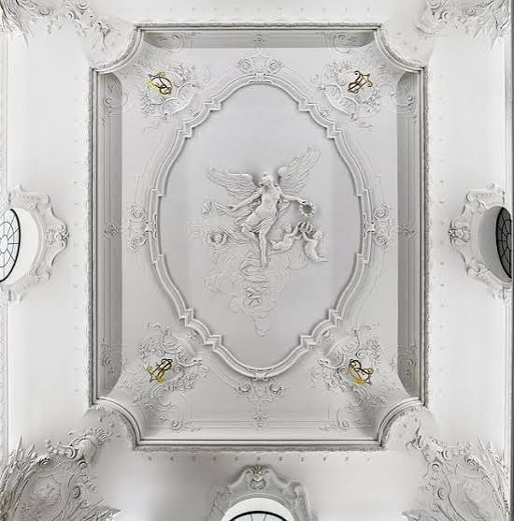

Look up! At the corners of the stucco ceiling above the “Englische Treppe” (English Staircase), two gilded symbols stand out in pairs. Each of these monograms consists of two letters intertwined almost beyond recognition. They are the initials of the Saxon royal couple, Albert and Carola: AR (for Albertus Rex = King Albert) and CR (for Carola Regina = Queen Carola). Under their patronage, the “Englische Treppe” underwent a Neo-Baroque redesign in 1895. Following the destruction caused by the war, this original state was reconstructed between 2005 and 2010.
In contrast to this case, monograms can sometimes serve as discreet evidence of authorship or as a signature. However, if knowledge of their meaning is lost, they appear enigmatic to us. Almost like a secret message, indecipherable and intended only for those in the know.
If you’re interested in secret messages and the history of cryptography up to our digital present, follow this “Crypto Trace” to the 2nd floor of the Residenzschloss and visit our exhibition “Crypto, what?” in the Münzkabinett. Maybe you’ll even run into Carola and Albert there?

Crypto Trace 2: With the “Visor” Closed
[http://www.skd.museum/krypto-was/qr2]

Riesensaal
Helmet, known as a "Rennhut"
Saxon, last third of the 16th century
Rüstkammer, Inv. No. M 0051

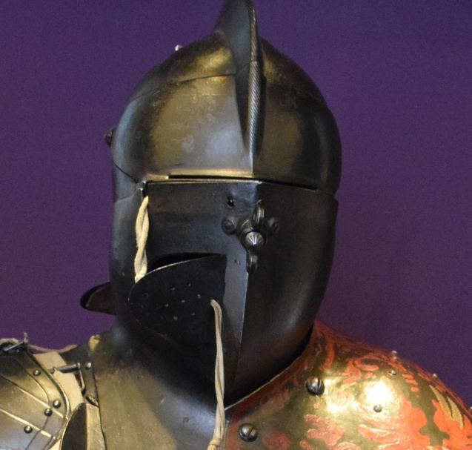

Ever since humans have been able to process metal, they have used bronze and iron for body armor in war and tournaments. To prevent head injuries, which could occur, for example, during the “Plankengestech,” a duel fought with blunted lances, all openings in this helmet were minimized: The face is protected by a flip-up brow guard and a chin guard screwed onto the helmet bowl. With the visor closed, the fighter is concealed and identifiable only by external distinguishing marks – in this case, the coat of arms painted on the left shoulder.
In the coexistence of anonymity and transparency, the riders are individually distinguishable by their coats of arms, while the individuals in armor remain anonymous. This principle resembles the logic of a blockchain. A blockchain is a decentralized, digital database where blocks of information are stored securely and chronologically. Holders of crypto assets remain pseudonymous within the network. This means they identify themselves using encrypted strings of characters instead of their real names. All of their transactions are publicly viewable and traceable. This is guaranteed by what is known as a public key, just like the individual coats of arms on the horsemen’s armor.
Does this connection interest you? Follow our “Crypto Trace” to the 2nd floor of the Residenzschloss and visit our exhibition “Crypto, what?” in the Münzkabinett. There, you’ll find out more about crypto assets and their significance in our digital world today.

Crypto Trace 3: For Insiders Only
[http://www.skd.museum/krypto-was/qr3]

Turkish Chamber
Pallasch
Blade: Milanese (?), hilt: Moroccan, mountings and blade decoration: Ottoman
Before 1577
Inv. No. Y 41

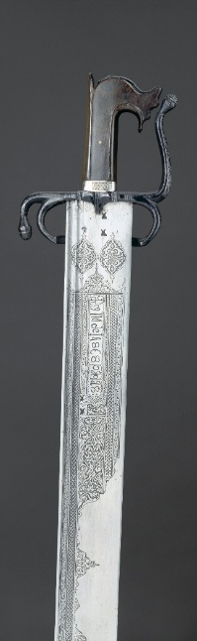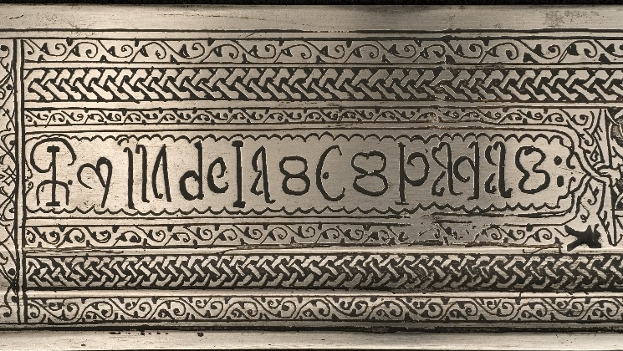

An artist, likely Ottoman, has etched ornaments and a mysterious inscription onto this exceptionally large blade. These are not words from a language of the eastern Mediterranean region, but rather a “secret language” based on Latin cursive script, in which letters are sometimes greatly simplified, sometimes doubled, or sometimes mirrored. The inscription can be deciphered as “Reyna de las espadas.” (“Queen of Swords.”)
The history of secret writing, or cryptography (from Ancient Greek: kryptós, meaning “hidden” or “secret”; gráphein, meaning “to write”), as illustrated by the enigmatic inscription on the blade, stretches far back in time. For example, about 2,500 years ago, the Spartans would wrap strips of leather around a wooden rod and write on them to convey secret messages. When unwrapped, the text was initially illegible. Only those who knew the exact diameter of the wooden rod could decipher the message on the so-called scytale.
If you’re interested in secret messages and the significance of cryptography right up to our digital present, follow this “Crypto Trace” to the 2nd floor of the Residenzschloss and visit our exhibition “Crypto, what?” in the Münzkabinett.

Crypto Trace 4: Shield with a Surprise
[http://www.skd.museum/krypto-was/qr4]

“On the Way to Electoral Power”
Arm shield with sword blade
Northern Italian, first quarter of the 16th century
Inv. No. N 70, XIV 9



Hidden inside this arm shield, which is painted with an ancient Roman battle scene, is a 64-cm-long retractable blade. Thus, what appears to be a defensive weapon, can also be used for attack in an emergency.
This example draws a parallel, perhaps surprising at first glance, to blockchain technology. The Blockchain features both active and defensive security elements that contribute to its protection: a chained structure of blocks, digital signatures, distributed storage of information, and transparency through the transaction history. As a result, once a transaction is confirmed, it becomes irreversible. Based on the current state of technology, these mechanisms ensure that the blockchain cannot be manipulated.
If you’d like to learn more about how a blockchain works and how this functionality fits into the long history of cryptography, follow our “Crypto Trace” to the second floor of the Residenzschloss and visit our exhibition “Crypto, what?” in the Münzkabinett.
Crypto Trace 5: The Secret Hideaway
[http://www.skd.museum/krypto-was/qr5]

Kunstkammer
Large Schifferstein Cabinet
Dresden, 1615
KGM, Inv. No. 47708

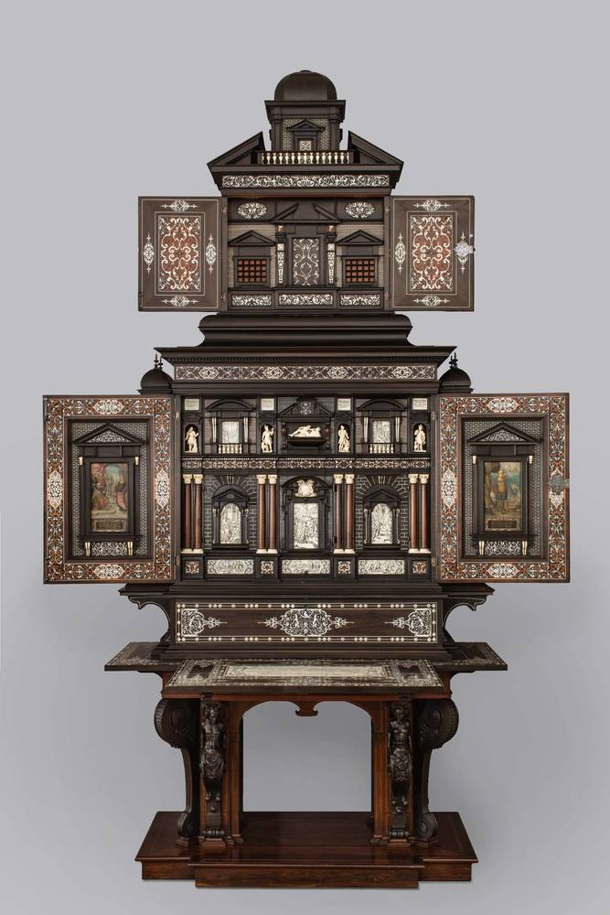

Elector John George I of Saxony acquired this large cabinet in 1615 for the enormous sum of 3,000 guilders from the Dresden cabinetmaker Hans Schifferstein. Hidden inside are 121 compartments and drawers; a pull-out spinet is also built into the space between the cabinet’s top and the table.
Artfully decorated cabinet chests like this one served, much like modern safes today, to store valuable and sensitive possessions. The complex design of such chests was intended to prevent potential thieves from finding the contents. In the age of crypto assets, this story continues in the digital realm, albeit with a shift: it is no longer the value itself that is preserved, but rather access thereto. Crypto assets exist as entries in the blockchain, and access is granted via a private key. The wallet safeguards this key. The key can be recovered at any time using the seed phrase, which is why the seed phrase is what truly needs protecting: today’s secret compartment.
Never heard of these terms before? That’s okay! If you’d like to find out more, follow our “Crypto Trace” to the 2nd floor of the Residenzschloss and visit our exhibition “Crypto, what?” in the Münzkabinett.

Crypto Trace 6: The Shooting Axe
[http://www.skd.museum/krypto-was/qr6]

Kunstkammer
Battle axe with a wheel-lock firearm
Presumably French, mid-16th century
Inv. No. T 0075

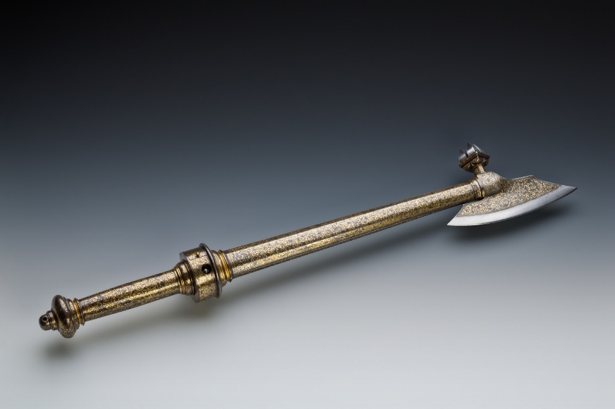

This magnificently gold-gilded battle axe conceals a wheel-lock firearm. A spiral-shaped main spring is in the handle. The ring-shaped capsule above it houses pyrite and a friction wheel. This unusual weapon is one of the earliest wheel-lock firearms in the Rüstkammer. But how does the mechanism of the hidden firearm in the battleaxe’s handle work? A piece of pyrite rubs against a rotating steel wheel; the friction generates a spark that ignites the charge. But before that happens, the spiral-shaped main spring must first be manually wound. No spark without prior effort!
In its logic, this mechanism is reminiscent of the “proof of work” principle of the Bitcoin system. This principle describes the fact that every transaction in the network must first be confirmed by participants using computing power. As a reward for providing this processing capacity, participants receive new Bitcoins and transaction fees.
If these technical details have sparked your interest and you’re curious about the history of cryptography and its digital present, follow our “Crypto Trace” to the 2nd floor of the Residenzschloss and visit our exhibition “Crypto, what?” in the Münzkabinett.

Crypto Trace 7: The Hidden Signature
[http://www.skd.museum/krypto-was/qr7]

Firearms Gallery
Long flintlock shotgun
Barrel: Widiewarddene the Elder Achari, Sri Lanka
Lock: Master MiW, likely Sri Lanka
Overall length: 2715 cm
Circa 1670
Inv. No. G 1548



This impressive ceremonial rifle was crafted around 1670 in Sri Lanka/Ceylon for a Dutch patron. At that time, the island was partially under the colonial rule of the Dutch East India Company (VOC). The 2.34 m long barrel is entirely decorated with magnificent silver inlay work by a local artist. On the underside of the barrel, the artist has left his signature in silver-inlaid capital letters: DEO[V]DERE WIDIE WARDDENE ACHARI, meaning “Widiewarddene the Elder.” The Sinhalese name suffix “Achari” indicates that Widiewarddene belonged to the blacksmith caste. The inscription can only be read if the barrel is disassembled. It is a kind of secret message for colleagues.
If you’re interested in secret messages and the significance of cryptography right up to our digital present, follow this “Crypto Trace” to the 2nd floor of the Residenzschloss and visit our exhibition “Crypto, what?” in the Münzkabinett.

Crypto Trace 8: Checkmate on the Battlefield?
[http://www.skd.museum/krypto-was/qr8]

New Green Vault
Chess Set
Ivory carver: Paul Heermann (attributed)
Goldsmith: Paul Solanier
Pieces probably Dresden, c. 1705; chessboard case probably Augsburg, c. 1705–1709
Inv. No. DL 2023/1



This ceremonial chess set, which has only recently come to light, ranks among the most spectacular masterpieces of European treasure art. The silver base and the box were crafted in Augsburg; the pieces, carved miniatures of the utmost individuality, can be attributed to the Saxon sculptor Paul Heermann (1673–1732).
Chess has captivated people for centuries. But would you have thought that chess players influenced the course of World War II? At Bletchley Park, a country estate about 70 kilometres northwest of London, cryptanalysts had been working since 1939 to decode the secret radio communications of the German Wehrmacht. The primary goal was to crack cipher machines such as the Enigma. The fact that the Allied code breakers had already succeeded in doing so as early as 1940 remained a secret until the 1970s. Initially, British secret service recruited academics. Later, it expanded its search and specifically approached renowned chess players, including Hugh Alexander, Harry Golombek, Stuart Milner-Barry, and James Macrae Aitken. The reason: chess and cryptanalysis require the same skills – logical thinking, the ability to recognize complex patterns, and foresight.
Does this story pique your interest? Follow our “Crypto Trace” to the 2nd floor of the Residenzschloss and visit our exhibition “Crypto, what?” in the Münzkabinett. There, you can see an original Enigma, the German encryption machine that was cracked in 1940.

